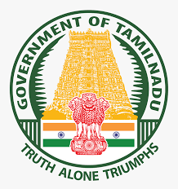

GOVERNMENT OF TAMIL NADU.

ORGANIZATIONAL SETUP OF

ARCHIVES AND HISTORICAL RESEARCH DEPARTMENT.

**HON'BLE MINISTER FOR HIGHER EDUCATION.**

ORGANIZATION SET-UP.

SECRETARY TO GOVERNMENT, HIGHER EDUCATION DEPARTMENT.

PRINCIPAL SECRETARY / COMMISSIONER OF ARCHIVES & HISTORICAL RESEARCH

SIX

ASSISTANT EDITORS.

1. ASST. COMMISSIONER, COIMBATORE.

2. RESEARCH OFFICER, MADURAI.

3. RESEARCH OFFICER, TIRUCHIRAPALLI.

4. RESEARCH OFFICER, SALEM.

5. RESEARCH OFFICER, THANJAVUR.

6. RESEARCH OFFICER, CUDDALORE.

ASSISTANT LIBRARIAN / LIBRARY ASSISTANTS.

RESEARCH OFFICERS.

RESEARCH ASSISTANTS / SUPERINTENDENTS.